Setting Up the Script With Tasks

Windows

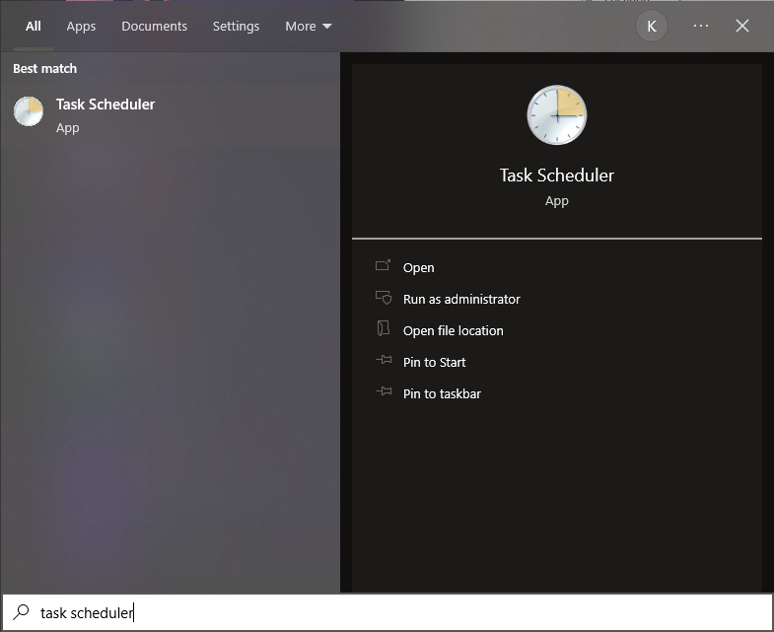
- Open task scheduler by searching for Task Scheduler in the start menu.
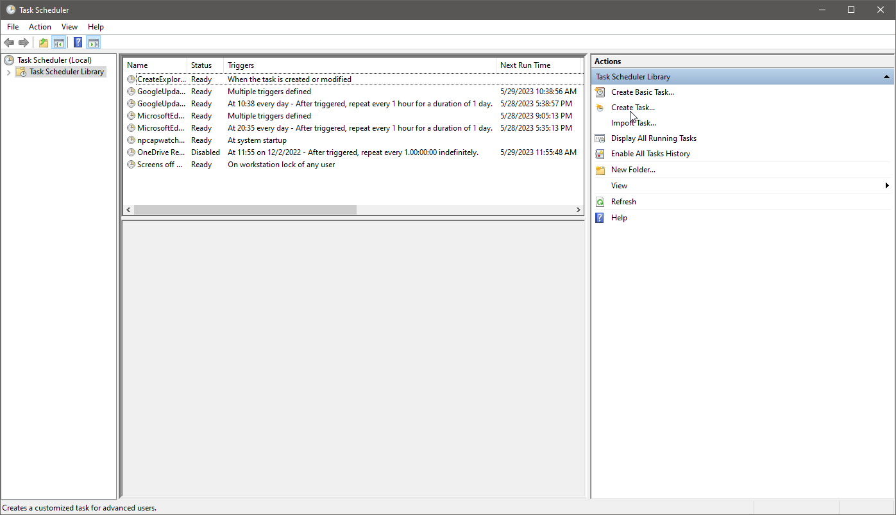
- On the right pane, click Create Task…
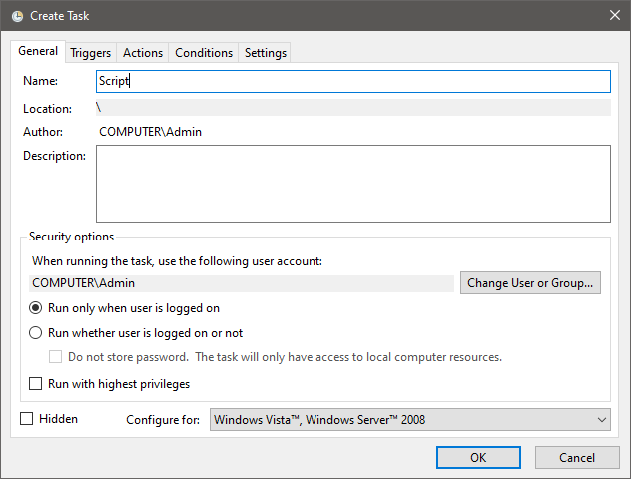
- Name the script.
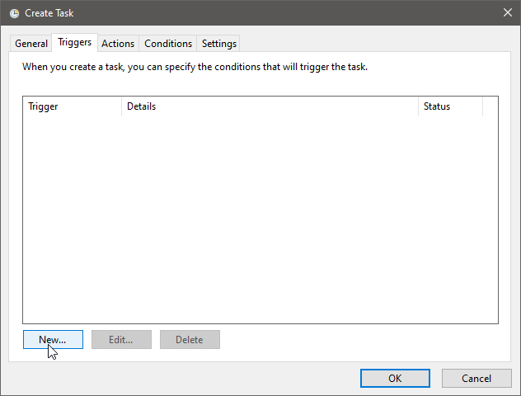
- Click on the Triggers tab, then the New… button.
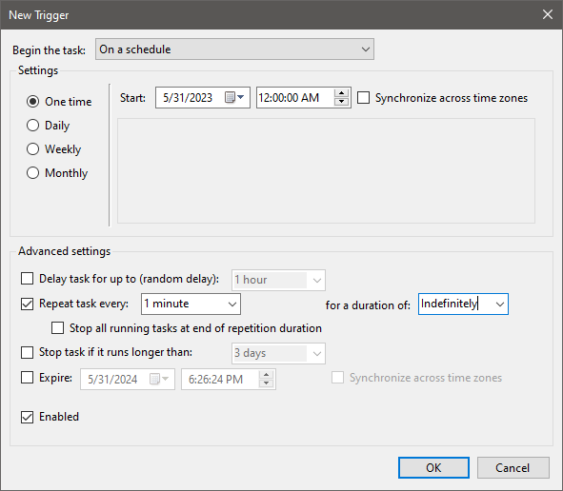
- Set the date you want the script to run, then set midnight as the time, check repeat task every and type 1 minute. Change ‘for the duration of’ to Indefinitely so it’s always running. Then click OK.
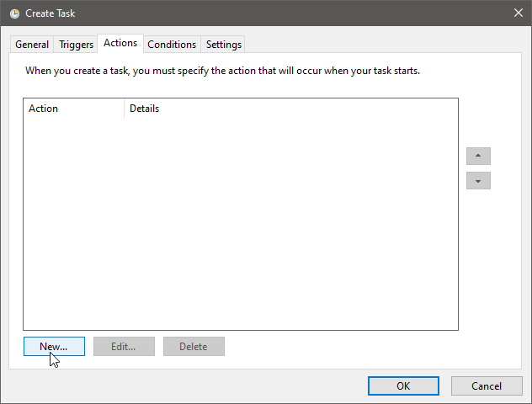
- Next, click the Actions tab and then the New… button.
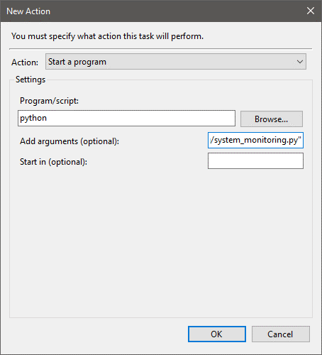
- Write python (or python3 – whichever your python is referred to in PATH) for the program/script field, then put the path to the script in quotes under add arguments. Click OK.
- Click OK once more and the task has been created.

Linux

- Open your crontab file using nano or any other text editor.
- On the next open line, type the following:
* * * * * /path/to/python /path/to/script.py
- Make sure to replace “/path/to/python” with your actual path to python and “/path/to/script.py” to the actual path to the script.
- Save and exit the file.

